1. Created a bitcoin wallet from Electrum.

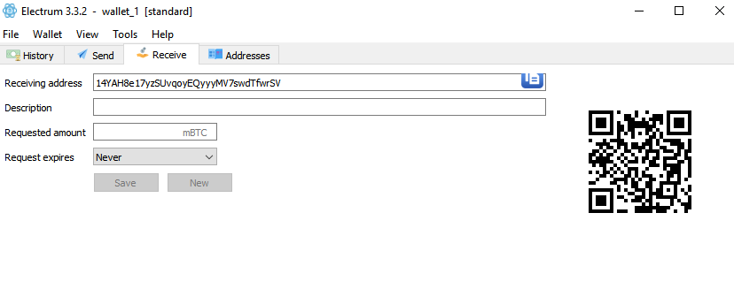

1. Navigated to a web application and generated a message

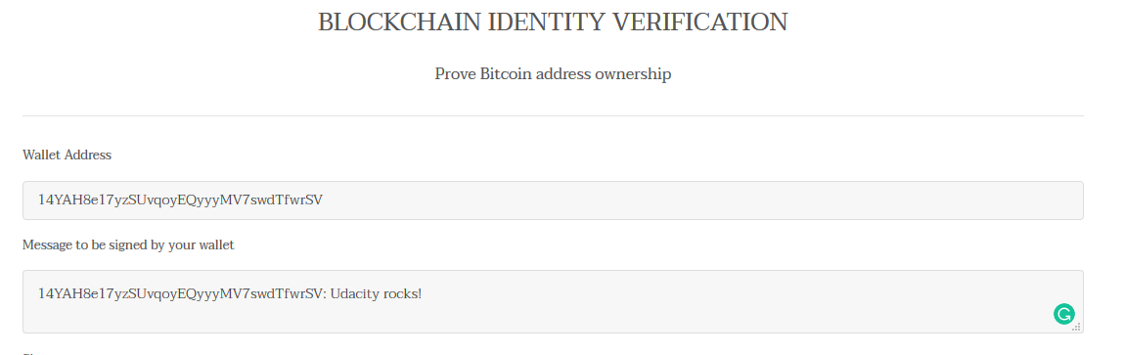

1. Generate a Signature for your wallet address ->
2. Generated through wallet

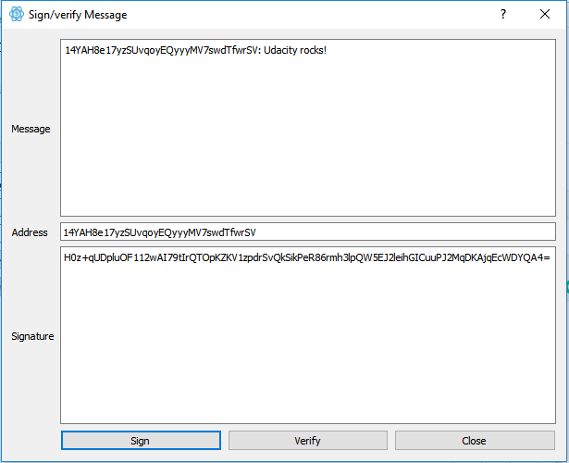

1. By using bitcoinjs-message javascript library to sign your address.

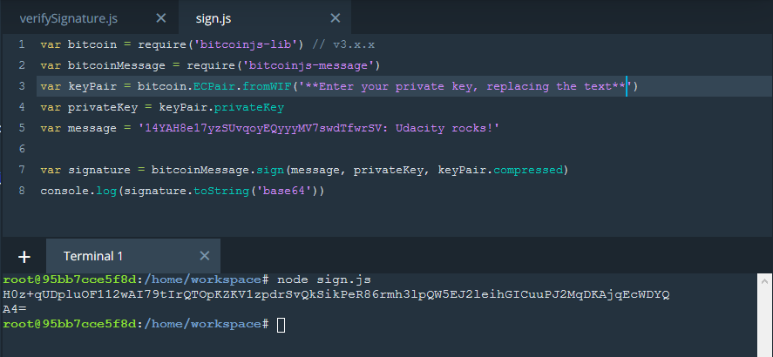

4. Validate this on web application of Udacity by filling the required details.

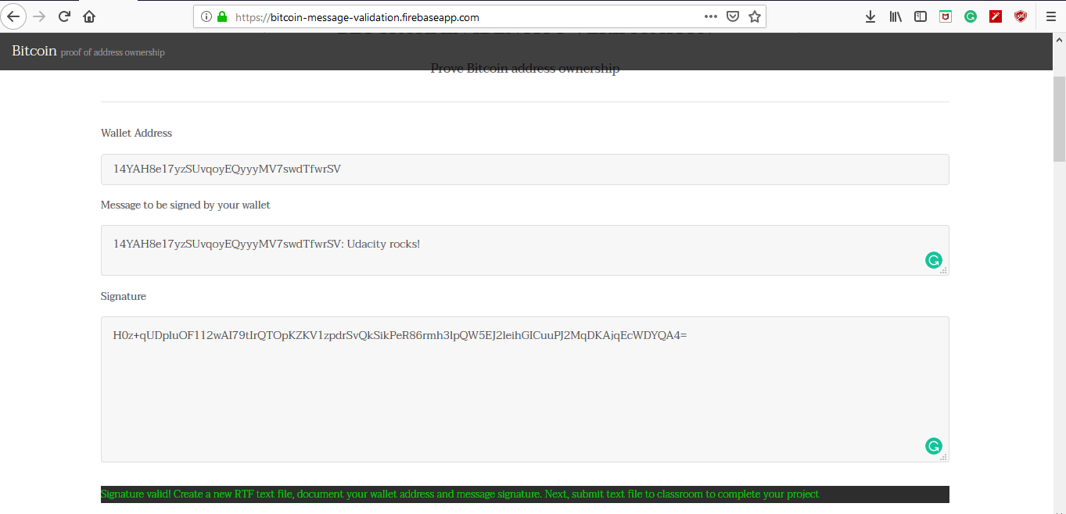

Wallet Address : 14YAH8e17yzSUvqoyEQyyyMV7swdTfwrSV

Message to be signed: 14YAH8e17yzSUvqoyEQyyyMV7swdTfwrSV: Udacity rocks!

Signature: H0z+qUDpluOF112wAI79tIrQTOpKZKV1zpdrSvQkSikPeR86rmh3lpQW5EJ2leihGICuuPJ2MqDKAjqEcWDYQA4=